# **Flood Risk Management for the IJssel River**

## Advice for the Province of Overijssel to manage uncertainties related to flood risk of the IJssel river using exploratory modelling.

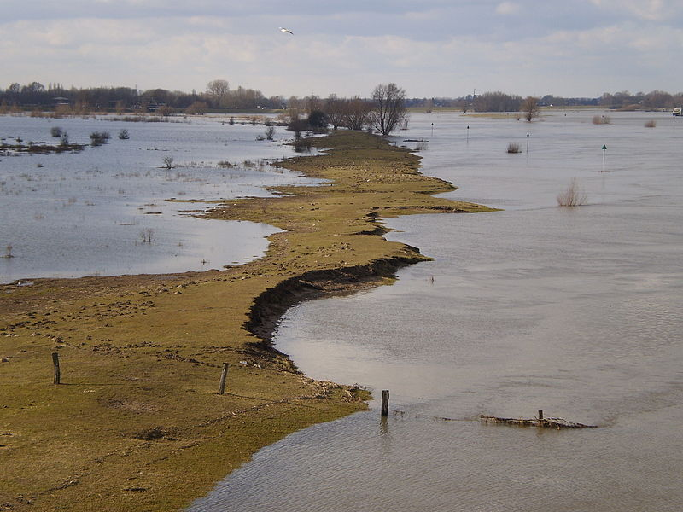

Martijn Ras: 5189268

Hongxuan Yu: 5008301

Paulus Meerman: 4383591

Supriya Krishnan: 906540 (Ph.D. researcher MAS)

**EPA 1361 | Model-Based Decision-Making**

### 

Glossary 2

**Part 1: Model based analysis and advice**3

Summary 3

Section 2: The Problem 4

Introduction 4

Current Situation 4

Policy options 5

Section 3: Approach 6

Methods 7

Open Exploration 7

Vulnerability Analysis 8

Scenario discovery 8

Optimization: MORDM (incorporated by MOEAs) 9

Section 4: Results 11

4.1 Open exploration 11

4.2 Scenario Discovery 13

4. 3 Sensitivity analysis 15

4.4 Robust Optimization 17

Section 5: Discussion 23

Main Policy Advice 23

Threats and limitations 23

Further research 25

**Part 2: Political Reflection** 26

References

**Appendices**

Appendix 1: Average uncertainty mean table 29

Appendix 2: Worst case uncertainty mean table

Cover photo: The IJssel river with flooded nature area with summer dike

Source: [Apdency](https://commons.wikimedia.org/wiki/User:Apdency)/ <https://nl.m.wikipedia.org/wiki/Bestand:IJssel_with_flooded_nature_area.jpg>

### Glossary

CBA: Cost-Benefit Analysis

DC: Delta Commission

EMA: Exploratory Modeling and Analysis

GSA: Global Sensitivity Analysis

LHS: Latin Hypercube Sampling

MC: Monte Carlo Sampling

MOEA: Multi-Objective Evolutionary Algorithm

MORO: Multi-Objective Robust Optimization

MORDM: Multi-Objective Robust Decision Making

NSGA: Non-dominated Sorting Genetic Algorithm

Nfe: Number of Functional Evaluations

PRIM: Patient Rule Induction Method

RfR: Room for the River

## **Part 1: Model based analysis and advice**

### Summary

This report presents policy advice to the Province of Overijssel to manage uncertainties that arise from flood risk for the IJssel river. Flood risk management is a multi-actor, cross-scale, polycentric problem where the values are diverse and knowledge claims can be contested. Hence, the problem and process are characterised by deep uncertainties (Walker, E., et al. 2012). The process of problem formulation and problem solving is intertwined primarily because knowledge claims can be contested and the stakes are fairly high. We use the Exploratory modelling and Analysis (EMA) Workbench for our analysis which helps systematically identify uncertainties and policy levers to manage this problem and find optimal solutions.

Based on the analysis, the advice for the Province of Overijssel is to raise their two dikerings (number 4 and 5) by 4 dm. There is no requirement to invest in an early warning system nor the need to participate in any Room for the River (RfR) projects. Based on the political debate and reflection, it is presumed that the neighbouring Province Gelderland may adopt a similar strategy which could bring down the overall costs. This strategy meets the main objectives of flood-risk management: to minimise economic damages and to minimise or mitigate risk of human casualties. Hence, in principle, this solution must be acceptable to the Delta Commission and Rijkswaterstaat, the owners of the larger national strategy.

The Political Reflection recognizes three aspects of implementing such a multi-stakeholder strategy: (1) **Narrow role of the analysts**: The role of the analyst was simplified as a truth finder.. In this perception there is an *apriori* of an expectation of an optimum which might be the case for a sole actor, but is rarely the case for the multi-actor systems; (2) **Taking a macro view**: In the real world, as seen in this study, analysis and outputs of static models were often challenged by value differences from actors, since most actors tend to focus on their own gains; and (3) **Arriving at a middle ground**: Mitigating the impacts of points (1) and (2) requires broadening the scope of the problem to arrive at a consensus regarding shared and conflicting values on risk distribution, financial trade-offs and immeasurable variables such as design quality. This consensus can feed into recommendations to formulate a framework for model practices, variables and runtime which underpins several choices. It is important to recognize that such any consensus (however broad) may not be in the interest of certain actors.

The objective of this exercise was set out at the onset, which makes the problem less unstructured. Despite this, the exercise was beset with two conflicts: (1) the assumptions to be considered for the model; and (2) communicating the process, impacts and outcomes of this model. The EMA Workbench is also based on a static model which may not include all outcomes of interest, especially the ones that cannot be quantified in simple numbers like biodiversity, cost of human life etc. There was a need to arrive at negotiated knowledge and a value-based trade-off to identify conflicts and propose acceptable policies.

### Section 2: The Problem

##### **Introduction**

The Overijssel province has commissioned this policy analysis exercise in light of developing a flood risk management plan for the upper branch of the IJssel River in the Netherlands, which impacts the Province.

In the next decades, modernisation of flood protection infrastructure such as dikes, gates, sluices, etc. are estimated to cost upwards of 2.2 billion euros. (Rijke, J, 2012). At the moment there is no single consensus among stakeholders on a flood risk management strategy for the region. This strategy hinges upon an ensemble of policies for different regions of the IJssel river which must be agreed upon by all stakeholders (or ‘actors’) involved. Any new investment must aim to be sustainable in the long-term future and must undoubtedly account for uncertainties arising from climate change. Hence, the presence of external and internal factors of influence on decision making lead to conflicting interests and makes the decision making process complex with no clear optimum strategies.

The aim of this report is to improve the decision-making process for uncertainties catering to the Province of Overijssel by analysing different policy approaches for flood-risk management for the IJssel river under conditions of deep uncertainty. The analysis recognizes the conflicts of interest of the different actors involved through prior interactions and debates and strives to present a strategy that minimises (if not add to the) negative consequences for other actors. .

##### **Current Situation**

Flood risk and water management in Overijssel largely depends on the protection offered by dikes which is proving insufficient in the face of rising climate hazards and increased amount of meltwater upstream. Flooding events between 1993 and 1995 have temporarily displaced 12.000 people and have flooded more than 18.000 hectares in Limburg (see Fig. 1). It is recognised that the amount of water expected to be handled by the rivers will increase even further. This led to the formulation of the Room for the River Policy by the Dutch government. The Rijkswaterstaat have started an integrated and elaborate process to develop and implement the necessary policies for the Dutch rivers. The implementation of the policies of the IJssel region is a part of this plan (Rijkswaterstaat, 2013).

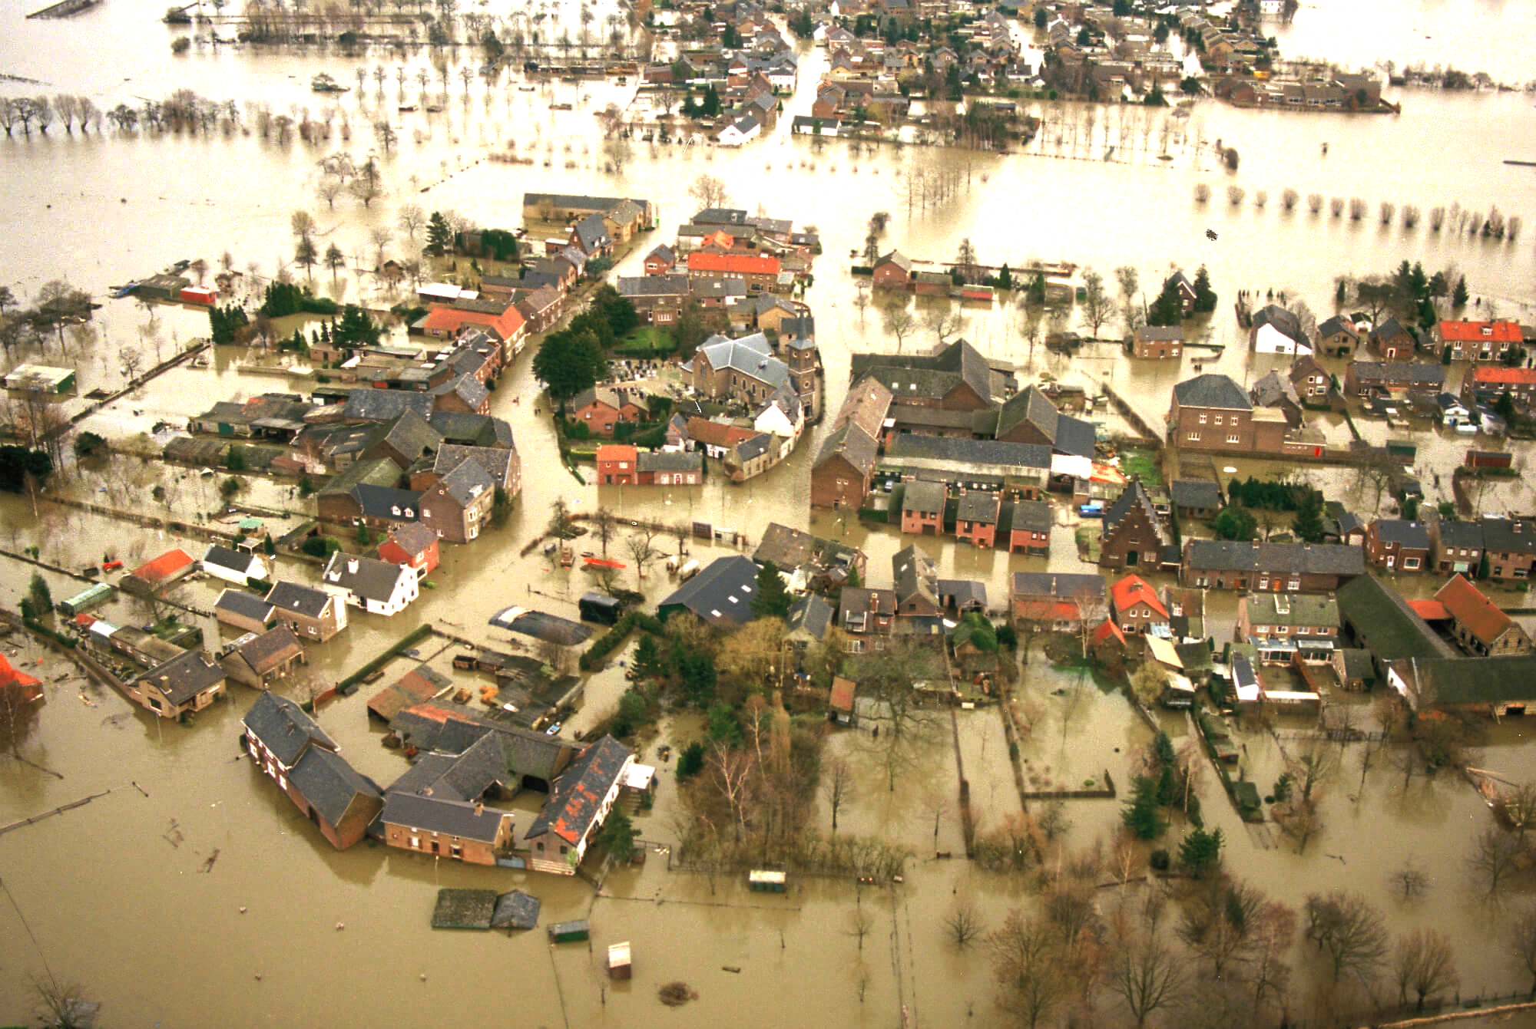

*Fig 1: The village of Itteren in Limburg after flooding of the Meuse river in 1995 (Foto: © Bart van Eyck)*

##### **Policy options**

For the IJssel River basin region, we explored two policy options: (1) heightening the dikes; and (2) Room for the River (RfR) to increase the water throughput capacity of the IJssel river in certain regions. Both options have advantages and pitfalls and the effects of implementing are complicated due to inter-relational effects. For e.g. Implementing a RfR policy upstream is beneficial for regions downstream as it reduces required dike heights. Such effects impact the financial and social implications of these measures and the future growth of the region.

We use state-of the art modelling techniques to assess different combinations of policies under different future scenarios using a set of predefined performance indicators:

* Expected annual damage (€)
* Expected number of casualties
* Dike investment costs (€)
* Evacuation costs (€)
* Room for the river costs (€)

The process of defining the uncertainties and incorporating it in the model to arrive at a clear policy advice for Overijssel have been explained step by step in the model file (*group15_codenotebook*) and can be read in parallel with this report.

This report presents the optimal policy for Overijssel, Gorssel (Dikering A4) and Deventer (Dikering A5). Ensuring fair distribution of costs, protecting economic development potential and conserving the unique agricultural traditions Overijssel has to offer are objectives that are pursued in parallel to the flood risk strategy. It is recognized in the report that above all the safety of the citizens living near the IJssel river must be ensured. Like all optimal policies, this policy runs the risk of being contested by other actors if it impacts them adversely. Hence, to present a broader insight of the decision-making context, we also present other proposals of the KPIs that are less optimal. This gives insight in the interests of the other actors and can be used for within the decision-making process. Our role as advisors to the Province of OverIJssel was to facilitate and aid the decision-making process.

### Section 3: Approach

The aim of the project is to develop a flood risk management plan for the upper branch of the

IJssel River in the Netherlands. A flood risk management plan, in addition to its main goal of managing the overflow of water (dike heights, river management, RfR measures), must address aspects of land-use (restrict building in vulnerable areas), transport decisions (locations of roads), environmental concerns and the preferences of the communities involved. This characterises it as a complex, multi-actor decision-making environment, which is riddled with deep uncertainties.

Policy making in an uncertain environment such as this depends on two aspects: the state of available knowledge and the convictions of the multiple decision makers involved. (Walker, E., et al. 2012) In this project, we are required to adopt the Exploratory Modelling framework that used computer-based models to analyse multiple such knowledge bases and convictions (Bankes,S. 1993).The simulation model uses a flood hydrograph to assess dike breaches and resulting economic damages and casualties at five locations along the IJssel river (Doesburg, Cortenoever, Zupthen, Gorssel and Deventer). The policy levers that could be used to manage economic and human losses are dike heightening, use of early warning systems and RfR initiatives.

A great advantage of open exploration is the ability to move from the ‘*predict and act*’ philosophy to ‘*explore and adapt*’(Dessai, S. et al, 2009). The model allows an exploration of ‘what if’ scenarios that could arise as a result of adopting different combinations of measures and assessing them to arrive at a set of acceptable scenarios. While the response to the problem of flood risk may be addressed using heuristics and intuition, over longer time horizons, the magnitude of uncertainty and actor dependencies increase. Flood risk management may involve small, medium and megaprojects (for e.g. Room for the River) which together with economic benefits (often overestimated), have large financial costs and environmental implications (often underestimated). A model quantifying scenarios and impacts may not completely consider environmental costs or a trade-off between human life and economic losses. Added impacts from climate change bring a whole new range of scenarios with varying assumptions (Walker, W.E. et al 2013). Spatial quality and design is another aspect which is heavily contested but cannot always be mathematically measured. This is where supporting qualitative studies and the political environment become critical. Ignoring these uncertainties could have adverse consequences and missed opportunities to make corrective decisions. Hence, not presenting a measurable input for the model may bias the decision-making process, if the relevant stakeholders do not present a convincing case. This will be explained in Part2: Political Reflection.

##### **Methods**

The Exploratory modelling process has four main steps: (3.1) Open exploration, (3.2) Scenario Discovery, (3.3) Sensitivity Analysis, (3.4) Optimization (Multi-Objective Robust Decision Making) (Kwakkel, J. 2013). The codebook can be found in the folder *EPA1361_group15_finalassignment.* It is possible to reproduce the results of the model by placing the codebook in the folder ‘final assignment’ under ‘<https://github.com/quaquel/epa1361_open>’. The following sections elaborates on the rationale of selecting each step and the description of each step (see Fig. 2).

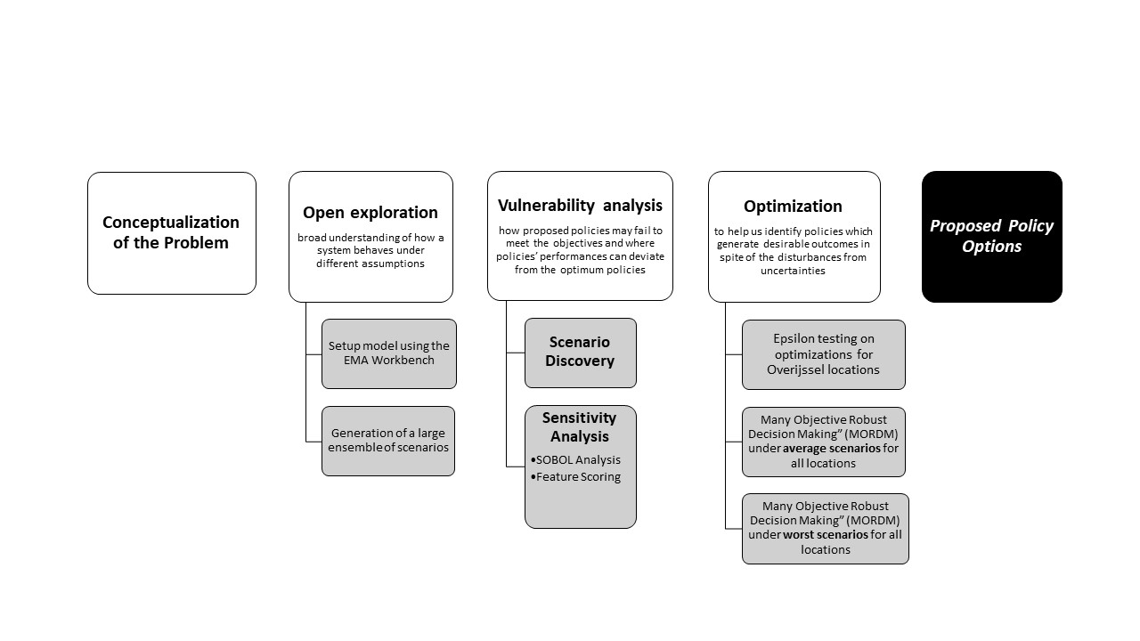

*Fig. 2: Sequence of actions to arrive at final policy options (with reference from Hamarat C., Kwakkel J., et al 2013)*

##### **Open Exploration**

Open Exploration is used for a broad understanding of how a system behaves under different assumptions (climate, risk management measures, damages, etc). Through multiple possibilities it enables decision-makers to move from a definite ‘what next’ to a more open ‘what ifs’ that can be discussed amongst stakeholders. The outputs can be sampled through different types of distribution or sampling methods. In order to not constrain the sample space, we deliberately chose a Monte Carlo sampling method. To avoid clustering errors, we run a very large number of iterations. We chose MC over LHS (which presents a stratified random sample) to be able to explore the full range of possibilities and not just the ones within fraction of error.

The EMA Workbench (<https://emaworkbench.readthedocs.io/en/latest/index.html>) allows capturing the problem as a function of the uncertainties (scenarios) and levers that impact the problem and gives a result. To get an idea of the current state of the problem, we run the base case, which is the model without any active levers (‘no policy’), and 25 random policies. We want to have all possible outcomes returned in order to aggregate them and get an overview of possibilities. This allows us to see more detailed points of interest, but also aggregated points of interest.

##### **Vulnerability Analysis**

Vulnerability analysis is a method to understand how proposed policies may fail to meet the objectives and where policies’ performances can deviate from the optimum policies (Bryant , B., Lempert, R. 2010). This assessment is done in two different parts: (1) Scenario discovery and (2) Sensitivity analysis.

##### **Scenario discovery**

Scenarios are a description of plausible future states of the world and the course of events which allows one to move forward from the actual to the future situation or explore alternative futures (Godet M., 2000). They act as a communication tool to characterise various uncertainties and vulnerabilities of proposed policies to different parties involved in the decision-making process to encourage reflection. The flood risk problem employs testing several policies under multiple scenarios. Hence, participatory computer-assisted scenario development (known as scenario discovery) aids assessment of a large set of simulation results. In this analysis, the Patient Rule Induction Method (Friedman. Fisher, 1999) will be applied to find simple descriptions of the input space that best predicts the interested outcomes.

The drawback of this method is that it often leaves out surprising or shocking developments, black swan events and conflicting interpretations of scenarios between actors makes it difficult to arrive at a consensus/trade-offs. As we already had a substantial set of scenarios, we could reuse the policies and scenarios from open exploration.

##### **Sensitivity analysis**

Sensitivity analysis is used to account for how uncertainties of model outputs can be connected to different sources of uncertainty in the input variables for the model. It is used to identify which uncertainty causes the largest variation, what has negligible impact, etc. to further modulate results. It is essentially a measure of the robustness of the model (Saltelli 2002). As the flood risk management is a complex environmental problem, we use Global Sensitivity Analysis (GSA), more specifically the first order sensitivity index- SOBOL. GSA is useful for models which combine a large number of uncertain variables to evaluate the full distribution of each input parameter across the domain of other parameters and also identify non-linear relationships between variables (Liu, Q., Homma, T., 2009). GSA adopts the ‘All-[factors]-At-a-Time’ (AAT) approach where all input factors are varied simultaneously to assess their impacts. This method sticks to quantitative analysis where inputs can be measured and reproduced.

SOBOL indices allow an assessment of individual variables on their own (S1) as well as understand interactions between variables (ST) (Sobol I.M., 1993, 2008). We choose SOBOL over methods such as Linear Regression and Random Forest for increased accuracy and better decomposition of the variance in model outputs, despite the method being computationally heavy.

SOBOL indices using a Monte Carlo sampling.

Using the EMA Workbench, 11 policies are formulated including 1 base case with ‘no active policies’. Using Monte Carlo sampling, the 10 random policies are run for 10000 scenarios each. The ‘no policy’ case is run for 1000 scenarios using Latin Hypercube sampling. The high number of scenarios are a result of several combinations of uncertainties (more than possible levers). Substantially higher number of runs also ensures that the policies are evaluated under full range of uncertainties (which is also a reason to choose the Monte Carlo method).

*Here, we would like to clarify that while Monte Carlo (MC) is deemed to be a good sampling method, we discovered that Latin Hypercube Sampling (LHS) is superior and preferable in such cases. This was much after the MC sampling had been initiated and in the interest of time we will stick to the MC results. At a later stage, If time permits, we will rerun the 10 policies using LHS to make a comparison. Alternatively, we can compare our results with other groups who may have used LHS to inform policies for Overijssel.*

Feature scoring (FS) is a machine learning technique used to illustrate the influences of various uncertainties and levers to the outcomes (called from the *scikit learn* library) (Pedregosa et al., 2011). It is fairly simple to generate and presents a visual overview of the uncertainties and levers that have a large influence on the selected outcomes of interest.

Next the model was rerun, this time using Sobol sampling to arrive at a minimum amount of runs to get an understanding of the uncertainties and their behaviour. Hence, the ‘no policy’ case had 1000 runs using the MC sampling and 4000 runs in the Sobol sampling. For Sobol we used 25 policies and 400 scenarios which resulted in 40000 scenarios in total. With this we can actually visualize the sensitivity of the uncertainties. In theory this process must also be applicable for policy levers, which would mean we set the actual policy levers as uncertainties and the uncertainties as levers. However, given the time and computational constraints we would like to leave this for post-processing and not include it in the scope of this report.

##### **Optimization: MORDM (incorporated by MOEAs)**

We now use the model to further optimise solutions for the Province and to see what combinations of policies work best for the main objectives of a flood risk management plan: minimizing damages and human casualties. Robust optimization methods are employed to help us identify policies which generate desirable outcomes in spite of the disturbances from uncertainties. Our optimization follows the framework of “Many Objective Robust Decision Making” (MORDM) incorporated by some Multi-Objective Evolutionary Algorithms (MOEAs) (Kasprzyk, J. et al., 2013). MOEAs are *posteriori* decision support tools which provide an explicit trade off to decision-makers before they can select solutions (generally a best approximate for a Pareto set) (Reed, P.M., et al,. 2013). In MORDM, a set of policies are tested under the possible future states of the world and solutions are selected if they are at the Parento front. Multi-Objective Robust Optimisation (MORO) is also a popular robust optimization method which considers a set of scenarios and optimizes the robustness of strategies over this set of scenarios (Hamarat et al. (2014), and it is particularly useful to identify trigger and signposts where policies must be modified or to to identify the Pareto approximate set of robust policy pathways (Kwakkel et al. (2015). MORO is superior to MORDM in that it optimizes robustness over a set of scenarios. The downside is that increasing robustness considerations in the search phase may affect the reference scenario (Bartholomew, E. and Kwakkel, J.H., 2020). But due to the time and equipment limitations, MORDM was adopted in this analysis.

In order to determine suitable epsilon values, some tests were carried out based on our objectives for Overijssel. The selected epsilon value is implemented in the optimizations for policies concerning all impacted locations. This is done to account for the multi-actor nature of decision-making. Moreover, it is to be believed Overijssel, which is led by the party of CDA, cares more about fairness rather than winning in this decision making arena (from the mandate provided to the Province of Overijssel). Therefore, the optimizations focused more on finding out favourable policies for all the actors. Next, the directed search was done in average scenarios, where all uncertainties are set to averages of their respective values. In addition, another directed search was executed under the worst scenarios and the uncertain parameters were all set at the most undesirable states. The motivation behind this design is to not only find optimal policies aimed at normal situations, but also provide some feasible solutions for the unwanted conditions.

However, an integral part of optimising policies is to recognise and integrate political concerns (Van Enst, W.I., et al., 2014). This means that the interests of other actors impacted by this policy must be acknowledged and considered for final policies. This may contest the optimality of the final policy and will require financial or environmental trade-offs. Arriving at a consensus needs to be done systematically.

### Section 4: Results

In this section, the results of model explorations and optimization is presented and discussed in four parts: (4.1) Open exploration, (4.2) Scenario discovery, (4.3) Sensitivity analysis and (4.4) Robust optimization. The codes and data related to the analysis are all available in a zip file in the submission folder.

##### **4.1 Open exploration**

Open explorations were carried out both for the base case (‘no policy’) and for the 10 random policies case. In the base case, 1000 scenarios were generated with zero investment costs. Fig 2 shows the distribution of total damage and total deaths. With no policy being implemented, the mean values of total damage and deaths are around 1.5e9 and 1.5 respectively. Among all the five locations, A1 (Doesburg) is expected to suffer the most damage and deaths.

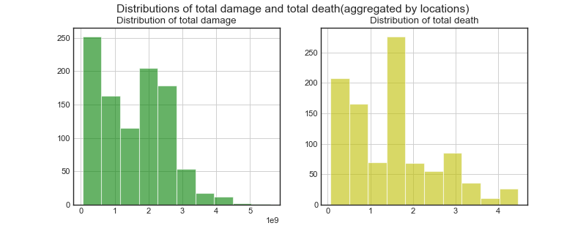

*Fig 3: Distribution of total damage and total deaths (aggregated by location)*

Compared to the base case, the 10 policies that run over 400 scenarios show reduced damages and casualties. As suggested in Fig 3, the average numbers of damages and casualties are around 4.7e7 and 0.02. The cases with policies show significant differences in the investment distributions from the no-policy ones. Thus, Overijssel needs to consider this trade off between investment costs and losses during the decision making arena.

*Fig 4: Expected damages at each location*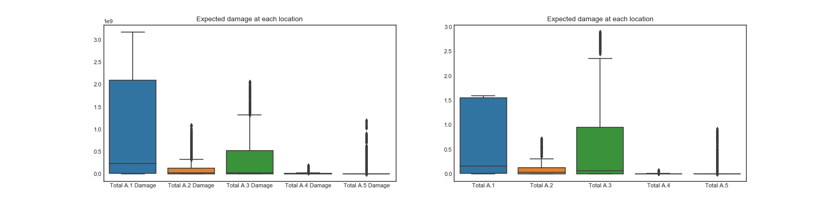

Fig. 4 and 5 shows the behavior of the interested outcomes. The damages, deaths at each location are aggregated based on the investments in heightening dikes, constructing Room For River projects and evacuation measures. The total damage is positively correlated to total deaths, and this corresponds with the fact that more destructive floods incur severe damages as well as more deaths. In addition, higher evacuation costs limit the number of deaths, which implies the investments in evacuation could help to reduce the casualties. However, from the results of open exploration, it is hard to reveal the explicit relationship between damage (or deaths) and the investments measures in protective infrastructure.

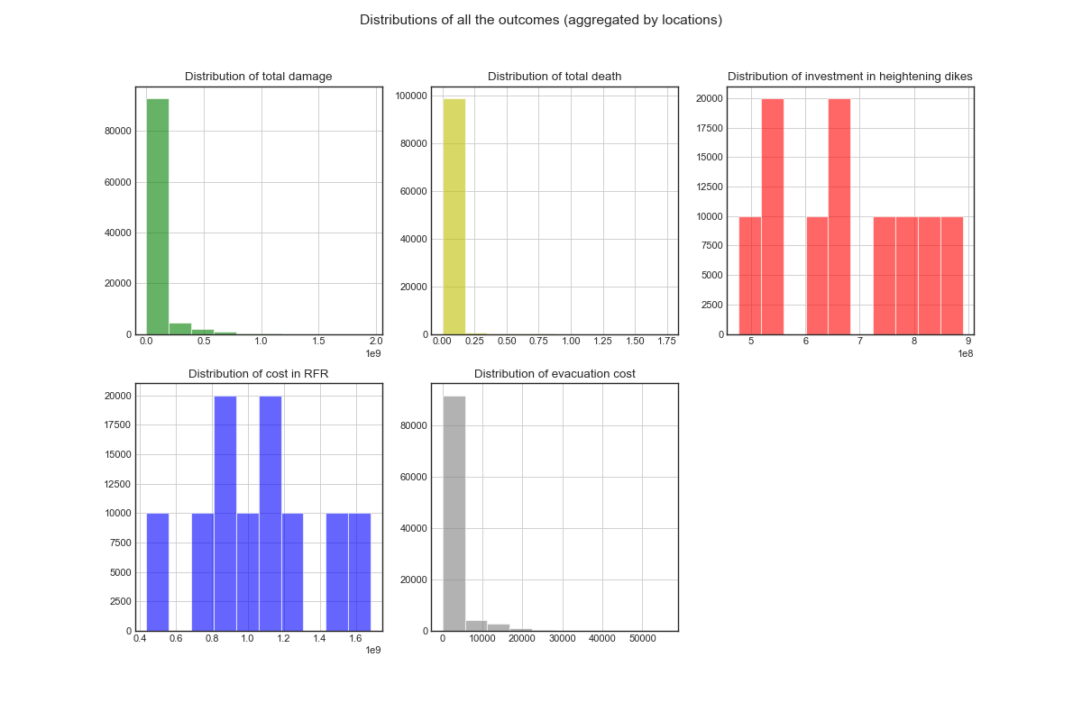

*Fig 5: Distribution of all outcomes (aggregated by locations)*

#### **4.2 Scenario Discovery**

For the vulnerability analysis, both the cases with ‘no policy’ and 10 policies were investigated. Since there is no investment cost in the no policy case, 'Total Damage” and “Total Deaths” are the outcomes of interest. For the cases with policies, we add another outcome named “(Investment) Costs” which includes costs for dike-heightening costs, Room For River and evacuation.

Firstly, it is important to determine the thresholds of all outcomes. Since there are no specific constraints predefined (including for costs), the thresholds are determined based on the percentages. It is assumed that around 60% outcomes are considered as unacceptably worst values. The EMA workbench is used to execute PRIM-oriented scenario discovery. This toolkit calculates the coverage, density information and the pq-values. Detailed information about this information over each case and outcomes can be found in the *exploration* codebook of the *group15_finalassignment*. (see Fig 6, Table 1).

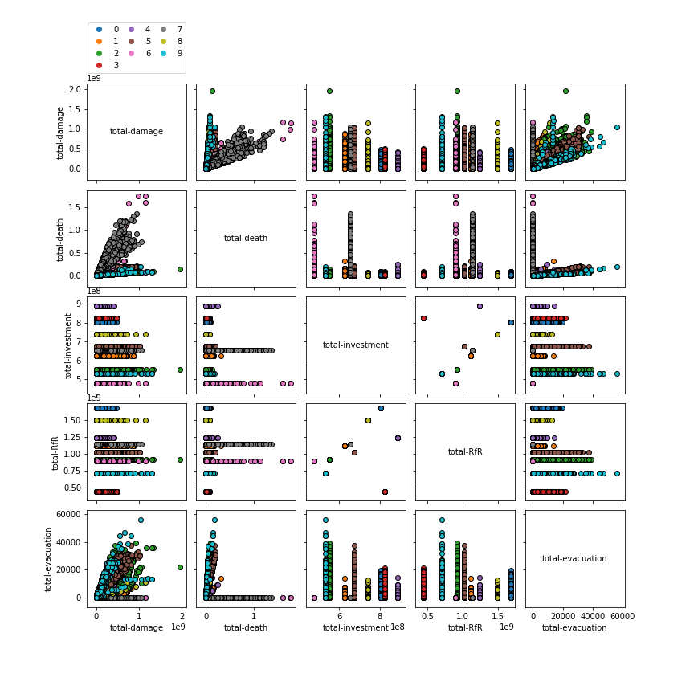

*Fig 6: Aggregate of all outcomes of interest (Total deaths. Total damages, Total costs) across the 5 locations.*

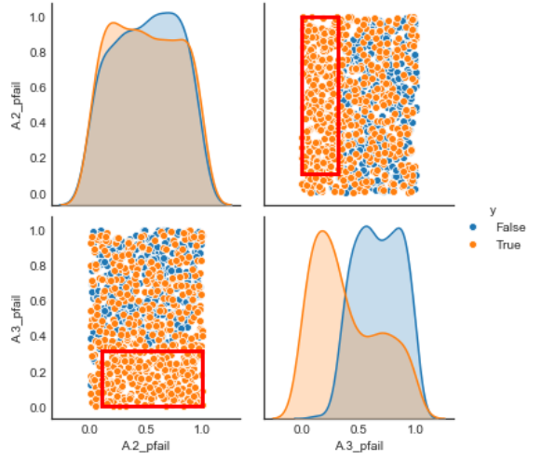

*Fig 7: PRIM subspace partitioning of “Expected deaths” under base case*

Inspecting boxes of analysis of “Total Deaths” in ‘no policy’ cases, we find that dike failure probabilities at A2 and A3 play an important role in defining high deaths scenarios (see Fig. 7). More specifically, when dike failure probabilities of A2 range between from 0.11 to 1 and that of A3 range between 0 to 0.31, the numbers of deaths are undesirable.

|  |  |
| --- | --- |
| **Outcomes of interested** | **Identified vulnerable factors and ranges** |
| Expected damage (no policy) | A1_pfail (0 - 0.39) |
| Expected deaths (no policy) | A2_pfail (0.11 - 1)  A3_pfail (0 - 0.31) |
| Expected damage (ten policies) | A4_pfail (0.1-1)  A3_DikeIncrease 1 (3.5 - 10)  0_RfR 1 (0.5 - 1)  A5_pfail(4e-5 - 0.65) |
| Expected deaths (ten policies) | A3_pfail (3e-5 - 0.59)  4_RfR 0 (0.5 - 1)  A5_pfail(4e-5 - 0.59)  A2_pfail(4e-6 - 0.6) |
| Expected costs (ten policies) | 1_RfR 1 (0.5-1) |

*Table 1: Results from Scenario Discovery*

##### **4. 3 Sensitivity analysis**

To visualize how each uncertainty and lever influences the outcomes (deaths, damages, costs), feature scoring is applied for the ten policies (see Fig. 8). The resulting visualisation illustrates that total damage is strongly influenced by the dike failure probabilities at A1(Doesburg), A3 (Zutphen) and A5 (Deventer). Dikes near A3 (Zutphen) and A5 (Deventer) also have a significant impact on the number of total casualties. The total investment costs are determined largely by the Room for river policy in dike ring 2 (Cortenoever) and dike ring 5 (Deventer).

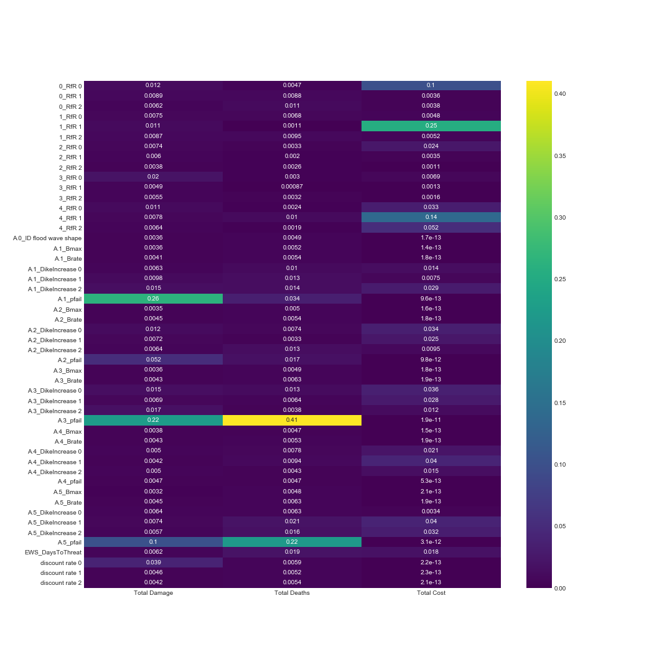

*Fig 8: Feature Scoring*

The global sensitivity analysis using Sobol consists of two parts, one containing no policies and the other containing 25 random policies. We did this to see if there were going to be huge differences. In the base case, 4000 scenarios were performed over outcomes of total damage and total deaths. As shown in Fig. 7, A.1_pfail is responsible for most of the damage followed by A.3_pfail at a little under half of A.1. This is exactly the other way around for deaths. All other uncertainties have been excluded as their impact is almost or exactly 0. This implies that the influences of dike failure probabilities in dikerings 1 (Doesburg) and 3 (Zutphen) on the total damage and deaths are significantly higher than all others. The two uncertainties should get prioritized in the further policy analysis stage where strategies will be formulated.

Fig. 9 demonstrates the results with the 25 random policies. In theory, sobol analysis should be consistent with the previous experiments that have 10000 scenarios run over 10 policies. But due to the long computational time, we decided to increase the number of policies while lower that of scenarios. S1 represents the individual effect of each factor on the outcomes, while ST manifests the overall effects including the interactions among factors. A.3_pfail still plays a dominant role in influencing total damage and deaths, but other uncertainties also have some influence over it which they did not have at first. The specifics as to why dike ring 3 seems most vulnerable are unclear.

|  |  |
| --- | --- |
|  |  |

*Fig 9: SOBOL analysis for expected damages and deaths using ‘no policy’ case (left) and 25 random policies case (right) over uncertainties.*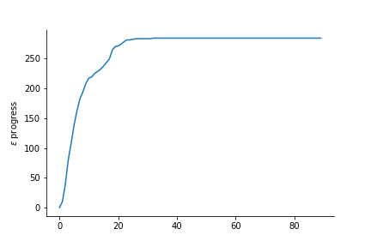

##### **4.4 Robust Optimization**

The optimizations started with testing the epsilon values. By running experiments for epsilon values of 0.025, 0.05 and 0.1, the one with 0.05 generated the most wanted number of solutions. Therefore, in the following optimizations, epsilon values were assigned as 0.05. It should be noted that the epsilon-testing experiments were done concerning the variables of A4 and A5, and the results suggest the optimal solutions in terms of the exclusive interests of Overijssel. In Fig.10, there are a few solutions which lead to near-zero deaths at total costs less than 100 million for Overijssel. However, these solutions turned out to be unrealistic in this multi-actor decision making context, as they demand large investments of Gelderland in the RfR project and leave low dike increase for Overijssel. Given consideration to this, as discussed in Section 3, the next optimizations would focus on the interests of all the impacted areas.

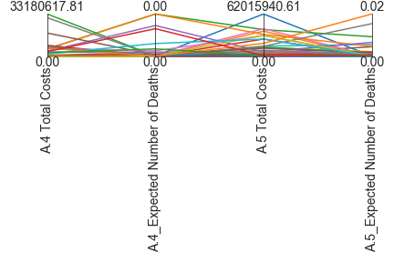

*Fig 10: The tradeoff plot for Overijssel’s interested outcomes, based on the optimization experiments (epsilon = 0.05) for dikering A4 and A5*

In the directed search for average scenarios, all the uncertainties were specified by their average values and MOEA was performed over 100.000 functional evaluations (nfe) by using default algorithm ϵ-NSGA2. 57 solutions were selected and re-evaluated under the uncertainties.The results still showed significant amounts of damage and deaths in general. (see Fig.12). But there are some solutions that have reduced both the damage and deaths compared to the base case where no policy is implemented. It is worth clarifying here that average refers to the average values in the parameters, which differs from the most common, or average cases in reality.

The solutions from average scenarios are based on the best and worst cases combined. However, it is also important for decision makers to have policies prepared for the worst scenario cases. For the optimization under the worst scenarios, nfe was reduced into 50,000 as it was sufficient to make the model convergence. This optimization also followed the framework of MORDM by formulating the scenarios with the worst possible values and 19 candidate solutions were found out. Figure 13 displays the overall behavior of these solutions.

*Fig 11: Plot of 17 solutions’ experiments, created with the worst case uncertainty.*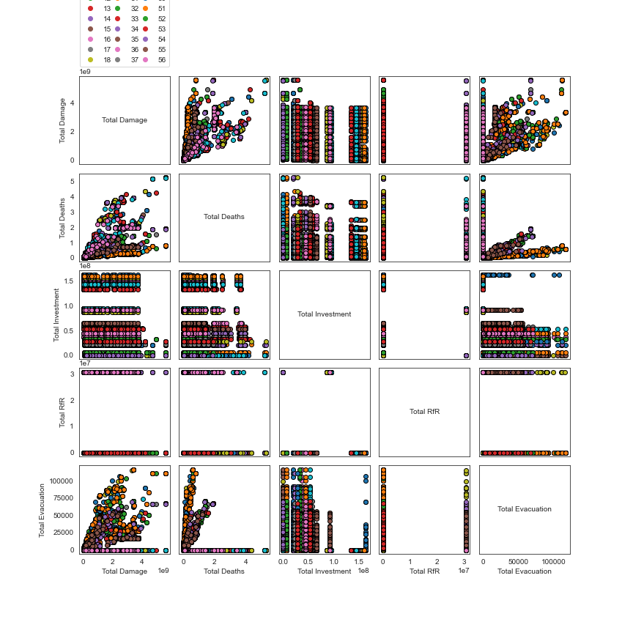

*Fig. 12: Plot of 56 solutions experiments created using average uncertainties.*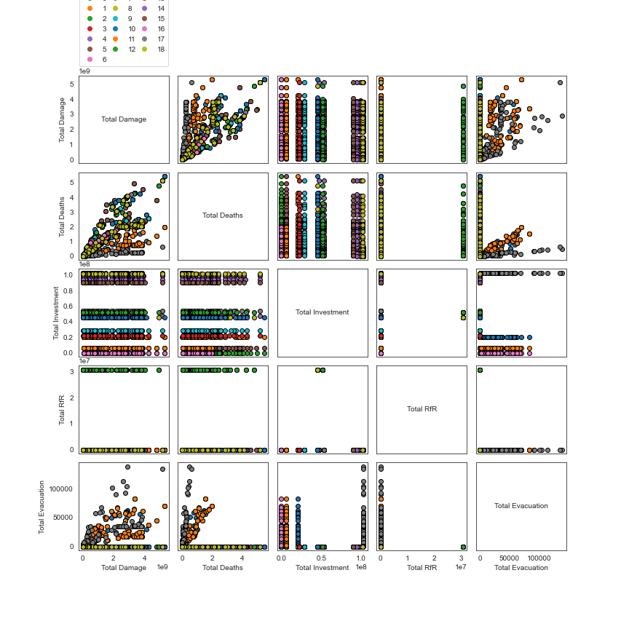

To better investigate the outcomes resulted by the candidate solutions, a table which shows the average (mean) values of each of the 5 variables per policy was created. The complete tables can be seen in appendix 1 and 2. As described in section 2, the safety of the citizens should be given priority when Overijssel forms flood risk management policies, thus, the 10th policy for average scenarios and the 17th policy for the worst cases are selected as the optimal policies (Table 2).

|  |  |
| --- | --- |
|  |  |

*Fig. 13: Maximum regret for each solution under average scenarios and worst scenarios*

|  |  |  |  |  |  |
| --- | --- | --- | --- | --- | --- |
| **Policy** | **Total Damage** | **Total Deaths** | **Total Investment** | **Total RfR** | **Total Evacuation** |
| avg_10 | 592932845.2 | 0.059814596 | 163389027.6 | 0 | 12121.15541 |
| worst_17 | 1457081334 | 0.141337145 | 102669839.2 | 0 | 27996.02994 |

*Table 2: Best outcomes of the solutions.*

Fig. 13 shows the maximum regret for each solution under average scenarios and worst scenarios. Maximum regret scores show how much worse one solution is compared to the best. Both the two policies perform well according to the number of deaths, however, the high maximum regret scores of total investments and evacuation costs mean that more monetary spendings are expected for all the involved actors.

The two policies provide two choices for the decision makers. Table 3 describes the specified policy levers of each policy. Policy 10 is a lot cheaper with only costing 756,333,993.96 as opposed to 1,559,779,169.23 of Policy 17. But Policy 10 only aims at the average scenarios and Policy 17 is the favorable policy for the worst case scenarios.

|  |  |  |  |  |  |  |
| --- | --- | --- | --- | --- | --- | --- |
| **Policy** | **EWS_DaysToThreat** | **A.1_DikeIncrease 0** | **A.2_DikeIncrease 0** | **A.3_DikeIncrease 0** | **A.4_DikeIncrease 0** | **A.5_DikeIncrease 0** |
| avg_10 | 0 | 3 | 2 | 4 | 4 | 4 |
| worst_17 | 0 | 3 | 0 | 2 | 2 | 2 |

*Table 3: Levers with values for best solutions.*

### Section 5: Discussion

##### **Main Policy Advice**

Based on the analysis in Section 4, we present two policy options to the Province of Overijssel. These were finalised based on the overarching goals to reduce casualties and damages as well as to reduce cost and minimise negative impacts to other actors.

1. **Option 1:** We suggest adopting Policy 10 of the average scenarios. Overall this presents the least deaths and damages. It is also relatively feasible to implement, and when checking again in the open exploration it did not show any weak points. In our opinion, costs must be divided fairly between different provinces. The requirements of the transport company can be satisfied as Room for the river projects will be implemented ensuring sufficient access to water transport. Citizens can feel safe, and in the small probability of a flood, the damages and deaths should be minimal.
2. **Option 2:** The second best solution is the Policy 17 for the worst scenarios. Since this policy is designed for the worst cases, It expects a significant amount of deaths, damages, and costs in comparison to the first option. But this solution could prepare Overijssel and other locations well for the most unwanted future. The costs are still fairly divided. It again does not contain any Room for the River projects.

##### **Threats and limitations**

**A. Rival problem framings**

Based on the policy recommendations mentioned above, the analysts reflect that instead of assuming the best possible outcomes (minimise deaths, damages and low investment costs), it may have been better to individually address these problem framings. This would have given a better overview of specific actors and their goals, instead of the overall goal. It might also result in a clearer understanding of the scope and limitations of the model. Given that there are only three actors involved in this exercise, Overijssel, Gelderland and Rijkswaterstaat/Delta Commission, this should have been easy to do. Other actors such as the transport company and environmental interest groups do not always have clear individual measurable goals for flood-risk management that are represented by their outcomes, thus making it impossible to account for it in the problem framing. This biases decision-making in favour of ‘building more’ which is a pitfall of a quantitative modelling process. The political arena needs to be able to complement this together and find best possible policy solutions. Modelling environmental and transport choices could also be done, though it would cost substantially more time.

**B. Model as a simplified version of reality**

A model is a simplified version of reality. It is natural that for some actors, important outcomes have not been incorporated. A static model such as this may not consider all relevant outcomes of interest and may not align itself with changing future conditions. This includes outcomes such as biodiversity, preservation areas, sea level rise, carbon or nitrogen emissions, etc. One of these, the rise of water level, is quite critical for determining floods. With low water it is harder to have a dike breach, whereas higher water would make it easier for a flood to occur. Having the water level as an outcome across the various planning steps would significantly improve the model and its usability, but also making it harder at the same time. With the water level in the model, the transport company could actually prove that water levels are too low for them.

**C. Resource constraints and impacts on outcomes**

The reason for choosing average uncertainties as the reference case looked very poor, due to the large amount of solutions. This was noticed after running the optimization and checking its results. Another optimization had to be performed but with lesser nfes due to time constraints. Thus the limitations have been done extensively with multiple reference scenarios and worst case reference scenarios have not been run as extensively as the average case scenarios. Similarly, runs for MORO are expensive, even for one set of results. Therefore we have MORO runs that are actually too small and therefore do not give adequate solutions. This should be taken into account while using the results. To make it perfect, equal runs of the worst case uncertainties as reference cases could still be used.

The sensitivity analysis is only performed on the uncertainties. While this is adequate, this could have been improved by also doing the analysis of the levers. Such an analysis could have improved our understanding of the levers, which could have resulted in a better selection of solutions. Also being able to immediately discard certain policies would help keep the solution space ordered and only have it contain the best policies. The Sobol sensitivity analysis could be used for the policy levers. The theory behind it is simple, have the model treat the uncertainties as levers and the levers as uncertainties. In this way you could run the analysis normally, even if you do not forget to set a nice policy lever (which is basically a reference scenario of uncertainties). *As time was limited and our first few tries failed, we decided to complete our existing analysis and try later.*

**D. Multiple tools and justifying selection of tools**

In the sensitivity analysis, a difference can be seen in the analysis plots for feature scoring cards and the sobol analysis, the most likely reason being that the data used in feature scoring was sampled using Monte Carlo, whereas the sobol analysis is sampled using Sobol. Monte carlo sampling is quasi-random, this makes it possible for the uncertainties to not be perfectly aligned. This also means that each and every experimental run can be different for Monte carlo. For further research, the data used in the feature scoring cards should be sampled using Latin Hypercube as this samples in such a way that each uncertainty is treated equally.

For the optimization part, although we did try the epsilon testings to find out the most suitable values, the experiments were executed too roughly. More experiments could have been conducted and the epsilon value for each outcome did not have to be necessarily the same. Besides, extra MORO optimizations could be done to compare with the results generated by MORDM.

##### **Further research**

Some of the further research is already partly explained above in ‘Threats and Limitations’.

**Improving Optimization Experiments**

The research can be improved by improving the optimization experiments for results more applicable in real-life situations. Our first choice of optimization was an average case, which did not make a good result for the worst case scenarios. As these uncertainties do not have a probability, it is more sensible to do a worst case scenario analysis in depth, instead of an average case analysis. This is mentioned because the average case might not be an average case, as it is more an average of the possible values.

**Enlarging understanding of policy levers**

Enlarging the understanding of the policy levers could be an advantage in analysing the policy levers in the solutions. It can be used for reasoning instead of the model itself. By knowing the sensitivity of a lever you could predict what lever is most useful for a given solution. This would mean any solution without this policy lever can be taken less seriously. Obviously, this depends heavily on the constraints or robustness functions that are used. If the aim is to reduce investments, and the most sensitive policy lever is expensive, thiat lever need not be included in the solutions at all.

For sensitivity analysis, the difference in the feature scoring card and sobol analysis may be eliminated by running the same number of policies using both, and to use LHS for the experiments in the feature scoring analysis.

## 

## **Part 2: Political Reflection**

The role of analysts at the science-policy interface is widely misunderstood. Analysts are expected to generate a scientifically rigorous model and optimal solutions to a problem (even when embedded within a broader context), which in an ideal world, would be acceptable to all actors and mandated for action by politicians. Achieving the correct balance between a technical and political discussion is key. Reality is somewhat muddier, as was illustrated through the process of modelling and the actor debate. In this reflection, the challenges of implementing our policy advice is explored and we present some directions to mitigate the risks associated with these challenges:

##### **Taking a macro view**

In the real world, as seen in this study, analysis and outputs of static models were often challenged by value differences from actors, since most actors (especially the smaller ones who do not contribute financially) tend to focus on their own gains. Hence, multiple problem framings for a common goal were essential

Despite the presence of a mandate for actors for a project with the goal of minimizing losses due to flood risks, the separation of reality and preferred outcome is not very clear. This makes problem framing important (Hisschemöller & Hoppe, 1995). The case study of the Ijssel river has a common goal (safety of citizens) which does not make it unstructured at the start. However, the pathways to reach the goal differs, impacting some actors in an unfavourable manner. The issue is the lack of a broader worldview in which the problem is situated. Smaller actors such as provinces do not necessarily concern themselves with issues of national safety (such as the Delta Programme and Room for the River). They not only will not contribute to it financially and do not want to suffer socio-economic consequences either (land submergence, displacement of people, etc). Moreover, profit-oriented actors such as the Transport Company with a single aim of not disrupting their business may not even align with the common goal of the project (Warner, Van Buuren, 2011).

Analysts have a role here to illustrate not just the optimal solutions but also the negative or worst-case scenarios that may occur if certain measures are not implemented. Rival framings of the same problem catering to each actor would be the key to enable a macro-view of the issue enabling a strong ground for consensus.

##### **Arriving at a middle ground**

This requires broadening the scope of the problem to arrive at a consensus regarding shared and conflicting values on risk distribution, financial trade-offs and immeasurable variables such as design quality.

In order to find an optimal solution, the ontological description of a problem determines which variables, or KPIs, are of importance (Driessen et al., 2010). Furthermore, a wide set of assumptions, boundaries and unquantifiable variables give ample opportunity to politicize an analysis (Van Enst, W.I., et al., 2014). Each actor may have their own truth proven using a model. Hence, debating for what is correct is an exercise in argumentative ammunition.

During the debate, stakeholder dynamics are determined by tensions emerging from a fair risk-distribution and fair cost-benefit distribution (although ‘cost’ was not explicitly a mandate for any actor). Delta Commission and Rijkswaterstaat had the common goal of identifying a long-term strategy for flood-risk management for the Ijssel river. They are also the financiers of this project and the Rijkswaterstaat had the power to overrule any policy, even if all or no actor is satisfied, though they are open to other actors contributing.

The provinces and their respective dike rings shared the objective of protecting their people and assets from damages. This could be achieved by: (a) Building higher dikes (this displaces people, shields connection to the river); or (b) Adopt Room for the River projects (expensive, reduces the depth of water, provinces will have to give up land). Each alternative impacts provinces differently.

The Transport company, true to their mandate, strongly supported the heightening of dikes to make sure water levels do not reduce, whereas, the Environmental Interest Group only supported Room for the River initiatives. This was a recurring tension in the debate. In addition to a fair distribution of risks and costs, the ethical trade-off of money and human lives must also be negotiated. No policy can claim to have completely mitigated a risk to human life. Though the Rijkswaterstaat works with a probability of 1 in 100000 people dying in a flood, quantifying this against not adopting a measure is plagued with ethical arguments.

##### **Narrow role of the analysts**

The role of the analyst was viewed as the truth finder by other non-analyst actors, which simplified the notion of the analyst. In this perception there is an *apriori* of an expectation of an optimum which might be the case for a sole actor, but is rarely the case for the multi-actor systems

As analysts of the Delta Commission (DC), our mandate was to cater to the requirements of the Commission. The problem itself is a case of deep uncertainty and working remotely in a multi-stakeholder environment also made it a ‘wicked’ problem where the boundaries between problem formulation and solutions are intertwined with each other (Kwakkel, J.H., et al 2016). Our challenge was to provide effective decisions under unavoidable uncertainty (Lempert et al. 2003). At the onset, our objective as analysts was also to go beyond the assigned tasks to broaden the scope of the problem and understand how to aid a forward-looking decision-making process.

Delta Commission (DC) is one of the prime actors in this developing the high-level strategy and holds veto powers to approve or scrap strategies irrespective of the viewpoint of other actors. As their analysts, we were assigned multiple tasks over the timeline of the project including:

* Organising meetings with other Actors to gather their concerns.
* Collecting and verifying data for their objectives and from other actors..
* Running analytical models.
* Substantiating research
* Verifying claims made by other actors. (For e.g. the claim by the transport company stating boats are better for the environment than trucks).

The experience working for the Delta Commission (DC) can be described as an example of what is not ideal in practice as a working relationship between a client and an analyst. The analysts did not have any tasks set out for them which made them unsure of their roles in the project. The larger goals of DC were unclear and it was only very close to the debate that the DC began to involve the analyst team in meetings. The DC, in the absence of Rijkswaterstaat, wants to act as an Actor that wants to build consensus amongst all actors, without strong mandates for itself. What followed after that was multiple tasks on gathering data, analyzing it and verifying claims which had to be executed rapidly. The running of the model, which is a substantial part, was allotted very late in the process. This slowed down the optimization process which was complicated further because there were no clear goals. Political consensus building tool centerstage. This disagreement between different modelling practices and consequently different truth claims proved to be a hurdle during the debate. The amount and depth of information forthcoming from other actors also varied widely on policy levers. So we incremented each other policy randomly to get an overview of what the solution might entail. This practice, most of the time, prevented a certain alignment on the technical level before the debates.

The DC wanted the duration of the model to be set to 2100. So, we ran the model twice: once with a run time of eighty years and once with a normal run time of 200 years., so we could actually assess the outcomes for DC, but also for the other groups. So, the recommendation would be to have a technical meeting to agree on model practices and variables. (Van Enst, W.I., et al., 2014).

**Debate Proceedings**

The ambiguity of values of lives, costs, risk distribution, tradition and environmental stewardship are clashing and are not seen as commensurable. Not all such conflicts can be resolved using standard financial compensation packages. Such clashes are typical in the political arena. For example, in the presidential elections of Bush vs Al Gore, the result outcomes were so close that there was no technically accepted result based on the number of votes. In such a situation, the decision was made by democratic institutions agreeing within an established and accepted judicial framework (Sarewitz, D. 2004).

Focused coping strategies must be devised based on what arguments are expected in the political arena. (For e.g.,Overijssel offered to compensate for some costs, which was not sufficient as per Gelderland) (Stewart, 2006; Thacher & Rein, 2004). Six major coping strategies summarized by Graaf et al, (2016) are FireWalls, Bias. Casuistry, Cycling, Hybridization and Incrementalism.

In our case, the Hybridization strategy and Bias strategies would have helped to structure the value inputs for the analysts. The Bias strategy enables agreement of values that can be neglected in return for compensation. Implicitly this was done to preserve traditional agricultural land by supporting dike heightening. However, since its value was not quantifiably, it was not part of the used formula. The hybridization strategy aims at establishing consent over values and is especially developed for multi-sectoral public–private partnerships. In essence the case debate is a form of this, but the debate focused on more technical and CBA aspects and less on the convergence and defining values involved. By making the implicit values explicit beforehand the chance of anonymity and hostility emerging might decrease. Analysts can help determine if scenario and policy discovery show that certain values are not threatened. An analytical framework can then be established incorporating these values, and agreeing on good practices.

In conclusion, analysts should be clear about the uncertainties, so politicians can make informed choices (Stirling, 2010) and political decision-makers can be held responsible and accountable. (Turner, 2005). Transparency is critical and any technocratic decision made without transparency undermines the values and motives of the government/ organisation. Such distrusting perceptions have already emerged towards large inter and intra-national institutions such as WHO, WTO, U.N., IMF, World Bank and E.U. (Johnson, 2011; Armingeon & Ceka, 2014; Kramer, 1999).

Acknowledging this value framework in the democratic decision-making process under uncertainties will determine the success of this process.

***

### References

Armingeon, Klaus, and Besir Ceka. “The Loss of Trust in the European Union during the Great Recession since 2007: The Role of Heuristics from the National Political System.” *European Union Politics*, vol. 15, no. 1, 2013, pp. 82–107., doi:10.1177/1465116513495595.

Bankes, Steve. “Exploratory Modeling for Policy Analysis.” *Operations Research*, vol. 41, no. 3, 1993, pp. 435–449., doi:10.1287/opre.41.3.435.

Bartholomew, Erin, and Jan H. Kwakkel. “On Considering Robustness in the Search Phase of Robust Decision Making: A Comparison of Many-Objective Robust Decision Making, Multi-Scenario Many-Objective Robust Decision Making, and Many Objective Robust Optimization.” *Environmental Modelling &amp; Software*, vol. 127, 2020, p. 104699., doi:10.1016/j.envsoft.2020.104699.

Bryant, Benjamin P., and Robert J. Lempert. “Thinking inside the Box: A Participatory, Computer-Assisted Approach to Scenario Discovery.” *Technological Forecasting and Social Change*, vol. 77, no. 1, 2010, pp. 34–49., doi:10.1016/j.techfore.2009.08.002.

Dessai, Suraje, et al. “Do We Need Better Predictions to Adapt to a Changing Climate?” *Eos, Transactions American Geophysical Union*, vol. 90, no. 13, 2009, pp. 111–112., doi:10.1029/2009eo130003.

Enst, Wynanda I. Van, et al. “Towards Productive Science-Policy Interfaces: A Research Agenda.” *Journal of Environmental Assessment Policy and Management*, vol. 16, no. 01, 2014, p. 1450007., doi:10.1142/s1464333214500070.

Godet, Michel. “How to Be Rigorous with Scenario Planning.” *Foresight*, vol. 2, no. 1, 2000, pp. 5–9., doi:10.1108/14636680010802438.

Graaf, Gjalt De, et al. “Coping With Public Value Conflicts.” *Administration &amp; Society*, vol. 48, no. 9, 2016, pp. 1101–1127., doi:10.1177/0095399714532273.

Hamarat, Caner, et al. “Adaptive Robust Design under Deep Uncertainty.” *Technological Forecasting and Social Change*, vol. 80, no. 3, 2013, pp. 408–418., doi:10.1016/j.techfore.2012.10.004.

Hisschemöller, Matthijs, and Rob Hoppe. “Coping with Intractable Controversies: The Case for Problem Structuring in Policy Design and Analysis 1.” *Knowledge, Power, and Participation in Environmental Policy Analysis*, 2018, pp. 47–72., doi:10.4324/9781351325721-4.

“Introduction to Sensitivity Analysis.” *Global Sensitivity Analysis. The Primer*, pp. 1–51., doi:10.1002/9780470725184.ch1.

Johnson, Tana. “Guilt by Association: The Link between States’ Influence and the Legitimacy of Intergovernmental Organizations.” *The Review of International Organizations*, vol. 6, no. 1, 2010, pp. 57–84., doi:10.1007/s11558-010-9088-z.

Kasprzyk, Joseph R., et al. “Many Objective Robust Decision Making for Complex Environmental Systems Undergoing Change.” *Environmental Modelling &amp; Software*, vol. 42, 2013, pp. 55–71., doi:10.1016/j.envsoft.2012.12.007.

Kramer, Roderick M. “TRUST AND DISTRUST IN ORGANIZATIONS: Emerging Perspectives, Enduring Questions.” *Annual Review of Psychology*, vol. 50, no. 1, 1999, pp. 569–598., doi:10.1146/annurev.psych.50.1.569.

Kwakkel, Jan H., et al. “Coping with the Wickedness of Public Policy Problems: Approaches for Decision Making under Deep Uncertainty.” *Journal of Water Resources Planning and Management*, vol. 142, no. 3, 2016, p. 01816001., doi:10.1061/(asce)wr.1943-5452.0000626.

Kwakkel, Jan H., and Erik Pruyt. “Exploratory Modeling and Analysis, an Approach for Model-Based Foresight under Deep Uncertainty.” *Technological Forecasting and Social Change*, vol. 80, no. 3, 2013, pp. 419–431., doi:10.1016/j.techfore.2012.10.005.

Lempert, Robert, et al. “Shaping the Next One Hundred Years: New Methods for Quantitative, Long-Term Policy Analysis.” 2003, doi:10.7249/mr1626.

Liu, Qiao, and Toshimitsu Homma. “A New Computational Method of a Moment-Independent Uncertainty Importance Measure.” *Reliability Engineering &amp; System Safety*, vol. 94, no. 7, 2009, pp. 1205–1211., doi:10.1016/j.ress.2008.10.005.

Reed, P.m., et al. “Evolutionary Multiobjective Optimization in Water Resources: The Past, Present, and Future.” *Advances in Water Resources*, vol. 51, 2013, pp. 438–456., doi:10.1016/j.advwatres.2012.01.005.

Rijke, Jeroen, et al. “Room for the River: Delivering Integrated River Basin Management in the Netherlands.” *International Journal of River Basin Management*, vol. 10, no. 4, 2012, pp. 369–382., doi:10.1080/15715124.2012.739173.

Saltelli, Andrea. “Sensitivity Analysis for Importance Assessment.” *Risk Analysis*, vol. 22, no. 3, 2002, pp. 579–590., doi:10.1111/0272-4332.00040.

Sarewitz, Daniel. “How Science Makes Environmental Controversies Worse.” *Environmental Science &amp; Policy*, vol. 7, no. 5, 2004, pp. 385–403., doi:10.1016/j.envsci.2004.06.001.

Turner, Stephen. “Expertise and Political Responsibility: The Columbia Shuttle Catastrophe.” *Democratization of Expertise? Sociology of the Sciences Yearbook*, pp. 101–121., doi:10.1007/1-4020-3754-6_6.

Walker, Warren E., et al. “Uncertainty in the Framework of Policy Analysis.” *Public Policy Analysis International Series in Operations Research &amp; Management Science*, 2012, pp. 215–261., doi:10.1007/978-1-4614-4602-6_9.

Warner, Jeroen, and Arwin Van Buuren. “Implementing Room for the River: Narratives of Success and Failure in Kampen, the Netherlands.” *International Review of Administrative Sciences*, vol. 77, no. 4, 2011, pp. 779–801., doi:10.1177/0020852311419387.

“Room for the rivers”, Rijkswaterstaat. https://www.rijkswaterstaat.nl/water/waterbeheer/bescherming-tegen-het-water/maatregelen-om-overstromingen-te-voorkomen/ruimte-voor-de-rivieren/index.aspx. Accessed on: 19 June 2020

Friedman, J.H. & Fisher, N.I. (1999). Bump hunting in high-dimensional data. Statistics and

Computing, 9, 123-143. https://doi.org/10.1023/A:1008894516817

Sobol, I.M., 1993. Sensitivity estimates for nonlinear mathematical models. Mathematical modelling and computational experiments, 1(4), pp.407-414.

Sobol, I.M., 2008. Simulation and the Monte Carlo Method.

Pedregosa, F., Varoquaux, G., Gramfort, A., Michel, V., Thirion, B., Grisel, O., Blondel, M., Prettenhofer, P., Weiss, R., Dubourg, V. and Vanderplas, J., 2011. Scikit-learn: Machine learning in Python. the Journal of machine Learning research, 12, pp.2825-2830.

### Appendix 1: Average uncertainty mean table

|  |  |  |  |  |  |
| --- | --- | --- | --- | --- | --- |
| **Policy** | **Total Damage** | **Total Deaths** | **Total Investment** | **Total RfR** | **Total Evacuation** |
| 0 | 608425386.7 | 0.511685295 | 158847680.6 | 0 | 0 |
| 1 | 621711142.9 | 0.521825381 | 153331806.6 | 0 | 0 |
| 2 | 595643721.1 | 0.499624695 | 162147239.9 | 0 | 0 |
| 3 | 625424094.4 | 0.522590968 | 152210479.1 | 0 | 0 |
| 4 | 651587885.8 | 0.537063365 | 141852808.4 | 0 | 0 |
| 5 | 638034435.9 | 0.526409418 | 147368682.4 | 0 | 0 |
| 6 | 646636068.2 | 0.538725118 | 148173608.7 | 0 | 0 |
| 7 | 664366556.2 | 0.556556462 | 145281932.2 | 0 | 0 |
| 8 | 612086619.2 | 0.512372151 | 157726353.2 | 0 | 0 |
| 9 | 668963033.2 | 0.557967654 | 144160604.7 | 0 | 0 |
| 10 | 592932845.2 | 0.059814596 | 163389027.6 | 0 | 12121.15541 |
| 11 | 605827155.2 | 0.510640332 | 160089468.3 | 0 | 0 |
| 12 | 770199958.9 | 0.680761737 | 134608667.8 | 0 | 0 |
| 13 | 773451510.4 | 0.680284666 | 133597387.9 | 0 | 0 |
| 14 | 1262221624 | 1.425753586 | 43576003.55 | 0 | 0 |
| 15 | 971620292.1 | 0.909807375 | 59423021.44 | 0 | 0 |
| 16 | 782092792.5 | 0.668189967 | 93322051.71 | 30700000 | 0 |
| 17 | 1264452364 | 1.424250989 | 37255203.24 | 0 | 0 |
| 18 | 786694566.2 | 0.667405642 | 87001251.4 | 30700000 | 0 |
| 19 | 1223744025 | 1.075179745 | 54862719.29 | 0 | 0 |
| 20 | 1693244531 | 0.220607167 | 20299287.63 | 0 | 34446.24387 |
| 21 | 1857354654 | 1.756669715 | 6320800.31 | 0 | 0 |
| 22 | 1264452364 | 0.512730356 | 37255203.24 | 0 | 23455.43159 |
| 23 | 1074576075 | 1.093188444 | 57554490.86 | 0 | 0 |
| 24 | 971620292.1 | 0.327530655 | 59423021.44 | 0 | 16830.3156 |
| 25 | 1321987528 | 1.24795714 | 52994188.72 | 0 | 0 |
| 26 | 970544012.2 | 0.913463377 | 65743821.75 | 0 | 0 |
| 27 | 1074576075 | 0.39354784 | 57554490.86 | 0 | 19067.10892 |
| 28 | 1654221310 | 0.212468804 | 0 | 30700000 | 33157.76116 |
| 29 | 778632567.1 | 0.66842039 | 94333331.62 | 30700000 | 0 |
| 30 | 1859122658 | 1.755789843 | 0 | 0 | 0 |
| 31 | 1601180378 | 1.308672176 | 22167818.2 | 0 | 0 |
| 32 | 1223744025 | 0.387064708 | 54862719.29 | 0 | 17625.34818 |
| 33 | 1499410341 | 1.553535106 | 32694901.09 | 0 | 0 |
| 34 | 1693244531 | 1.470714444 | 20299287.63 | 0 | 0 |
| 35 | 1859122658 | 0.263368476 | 0 | 0 | 40783.68911 |
| 36 | 1264452364 | 0.213637648 | 37255203.24 | 0 | 38939.68135 |
| 37 | 1499410341 | 0.559272638 | 32694901.09 | 0 | 23861.74237 |
| 38 | 1859122658 | 0.632084343 | 0 | 0 | 24566.17509 |
| 39 | 1321987528 | 0.187193571 | 52994188.72 | 0 | 32824.1987 |
| 40 | 1693244531 | 0.5294572 | 20299287.63 | 0 | 20748.79631 |
| 41 | 1262221624 | 0.213863038 | 43576003.55 | 0 | 38705.79337 |
| 42 | 1499410341 | 0.233030266 | 32694901.09 | 0 | 39614.22074 |
| 43 | 1321987528 | 0.44926457 | 52994188.72 | 0 | 19771.75263 |
| 44 | 1601180378 | 0.196300826 | 22167818.2 | 0 | 31089.38219 |
| 45 | 970544012.2 | 0.328846816 | 65743821.75 | 0 | 16718.00074 |
| 46 | 1262221624 | 0.513271291 | 43576003.55 | 0 | 23314.54848 |
| 47 | 1601180378 | 0.471121983 | 22167818.2 | 0 | 18726.7808 |
| 48 | 1599717905 | 1.31065703 | 28488618.51 | 0 | 0 |
| 49 | 1654221310 | 1.416458692 | 0 | 30700000 | 0 |
| 50 | 1599717905 | 0.196598554 | 28488618.51 | 0 | 30924.65139 |
| 51 | 1857354654 | 0.263500457 | 6320800.31 | 0 | 40617.72134 |
| 52 | 1857354654 | 0.632401098 | 6320800.31 | 0 | 24466.20391 |
| 53 | 1599717905 | 0.471836531 | 28488618.51 | 0 | 18627.55472 |
| 54 | 1654221310 | 0.509925129 | 0 | 30700000 | 19972.67496 |
| 55 | 845432465.6 | 0.28175199 | 92464801.05 | 30700000 | 12997.21104 |
| 56 | 845432465.6 | 0.782644417 | 92464801.05 | 30700000 | 0 |

### Appendix 2: Worst case uncertainty mean table

|  |  |  |  |  |  |
| --- | --- | --- | --- | --- | --- |
| **policy** | **Total Damage** | **Total Deaths** | **Total Investment** | **Total RfR** | **Total Evacuation** |
| 0 | 1701361045 | 0.524287477 | 20299287.63 | 0 | 20984.70644 |
| 1 | 1701361045 | 1.456354104 | 20299287.63 | 0 | 0 |
| 2 | 1816190341 | 1.694514267 | 0 | 0 | 0 |
| 3 | 1630831773 | 1.324787008 | 22167818.2 | 0 | 0 |
| 4 | 1595752137 | 1.292733522 | 47205032.2 | 0 | 0 |
| 5 | 1816660025 | 1.698026863 | 6320800 | 0 | 0 |
| 6 | 1816190341 | 0.610025136 | 0 | 0 | 24014.82397 |
| 7 | 1595392411 | 1.296200869 | 53525832.2 | 0 | 0 |
| 8 | 1549062935 | 1.23040087 | 45336501.63 | 30700000 | 0 |
| 9 | 1633575947 | 1.330724817 | 28488618.2 | 0 | 0 |
| 10 | 1667117712 | 1.425051197 | 45336501.63 | 0 | 0 |
| 11 | 1816660025 | 0.611289671 | 6320800 | 0 | 23983.60937 |
| 12 | 1551102003 | 1.236120241 | 51657301.63 | 30700000 | 0 |
| 13 | 1482886636 | 1.199278437 | 98885262.2 | 0 | 0 |
| 14 | 1515894760 | 1.225739169 | 94311968.2 | 0 | 0 |
| 15 | 1508252698 | 1.218801271 | 90023447.2 | 0 | 0 |
| 16 | 1476605415 | 1.196814263 | 99896542.2 | 0 | 0 |
| 17 | 1457081334 | 0.141337145 | 102669839.2 | 0 | 27996.02994 |
| 18 | 1463440744 | 1.180345449 | 101658559.2 | 0 | 0 |